|  |  |  |  |  |  |
| --- | --- | --- | --- | --- | --- |
| Date | 28-Nov-22 | | | Tester Name | Richard Belanger |
| Environment | Penfax - Test | | | Login used | TEST2 |
| Operating System | Windows | Version: | Update: | | |
| Software Used | Edge | Version: | Update: | | |
| Not Applicable | Version: | Update: | | |
| Release version | 22.4.1 | | | | |
| Title | M5. 02 Vested General 12 month member with small benefit | | | | |
| Test Type | Regression | | | | |
| Test Scenario | Member will be Terminated and payment produced | | | | |
|  |  | | | | |
| Expected Results | Member will be Terminated and payment produced with correct taxes withheld | | | | |
| Pass/Fail | Pass | | | JIRA# | N/A |

Describe your steps with screenshots:

Member is Vested

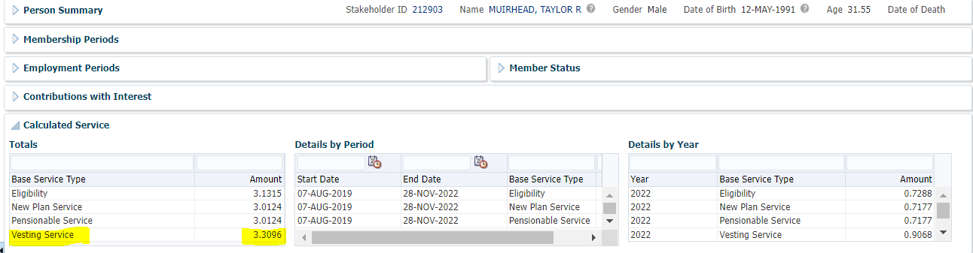

Terminate Member

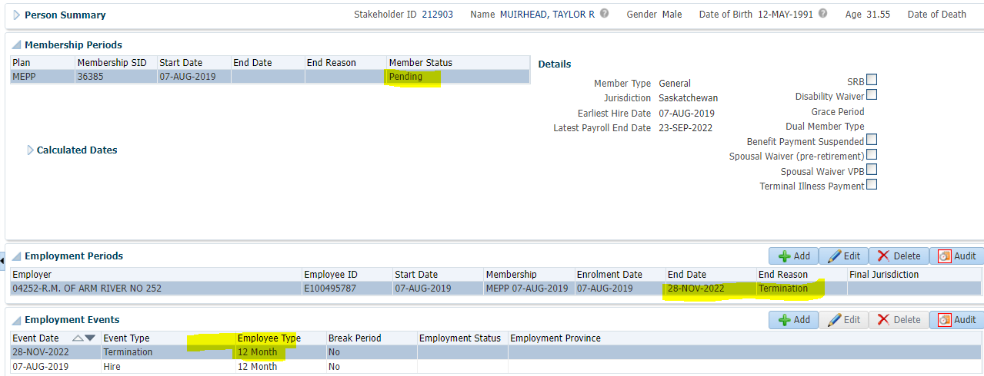

Member Profile>Benefit Calculation

Calculate

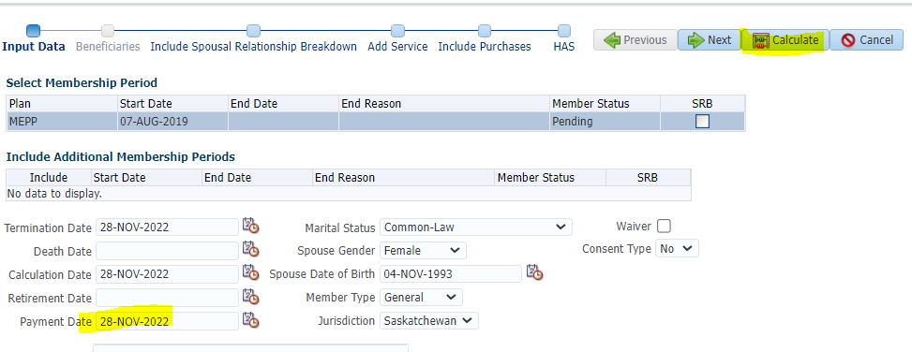

Member has a Small Benefit, not Locked-In>Process

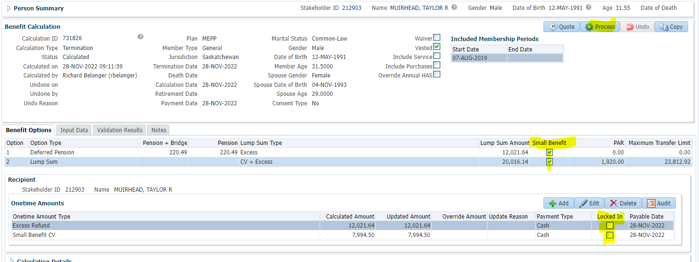

Processed > To Benefit Selection> Next

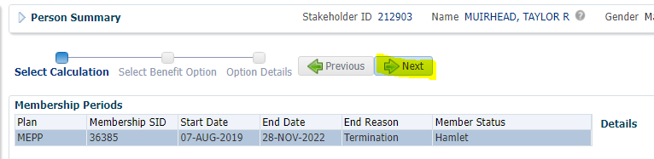

Choose Lump Sum line Add Payment Date>Next

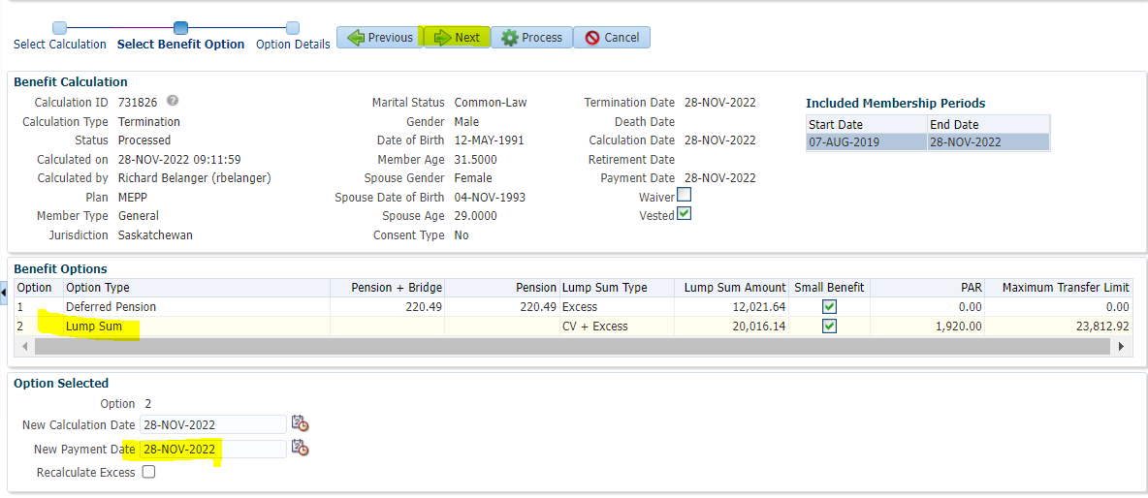

Send EXCESS Refund to Cash; Send Small Benefit CV to RRSP>Process

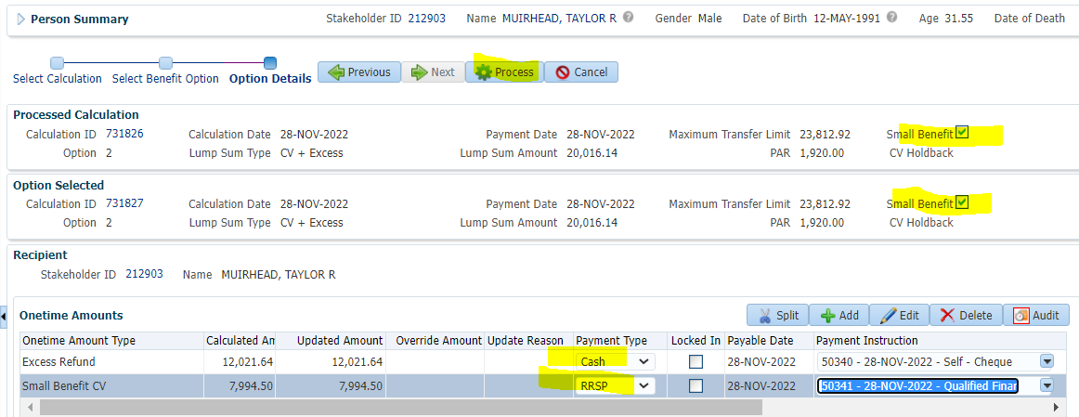

To Benefit Recipient

Submit the Payment lines for Approval>Approve

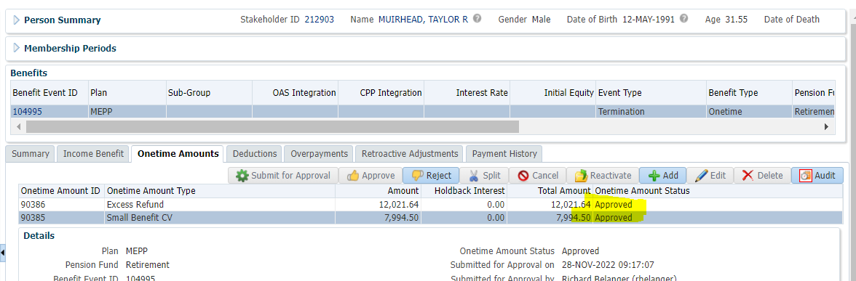

To Summary>Authorize

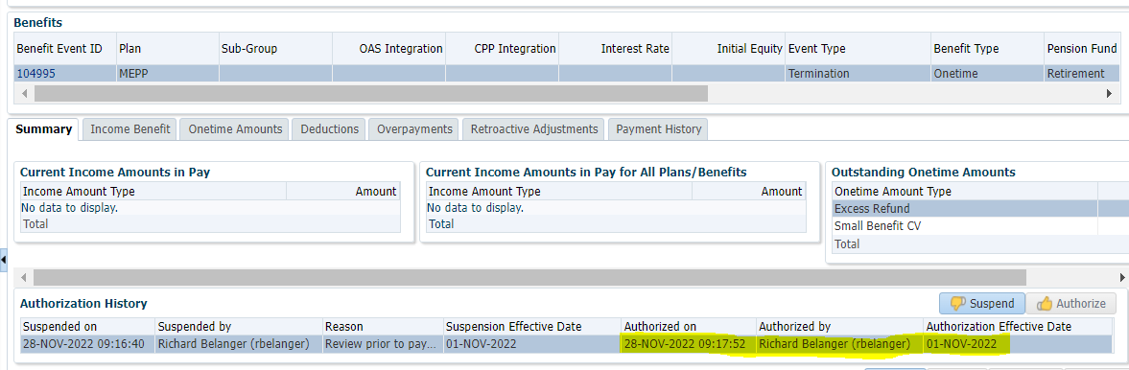

Payment produced via PENFAX Payment Production

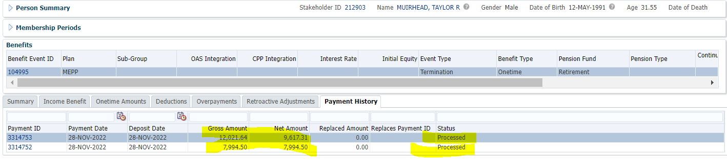

Tax Rates

0.00-4,999.99 = 10%

5,000.00- 14,999.99 = 20%

15,000.00+ = 30%

Excess Refund amount = 12,021.64; subject to 20% Tax;

12,021.64 x 20% = 2,404.33; 12,021.64 -2,404.33= $**9,617.31**

RRSP not subject to Tax; **$7,994.50**